**Day 20**

**Sprint 1 Submission**

**Name: Mriganka Patra**

**Emp ID: 2415820**

**Email: Mriganka.Patra@cognizant.com**

Task:

Write and execute manual test cases for SharePoint forms.

Manual Test Cases:

**Test Case 1: Form Validation - Required Field Check**

Description: Verify that the form prevents submission when required fields are left blank and displays appropriate error messages.

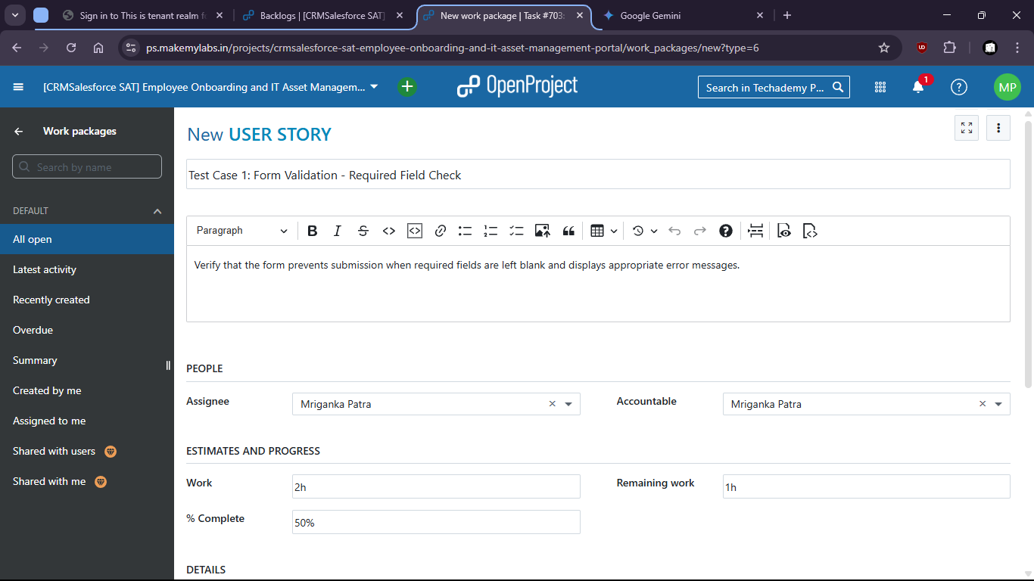

1. Test for the SharePoint form if blank field shows any error.
2. 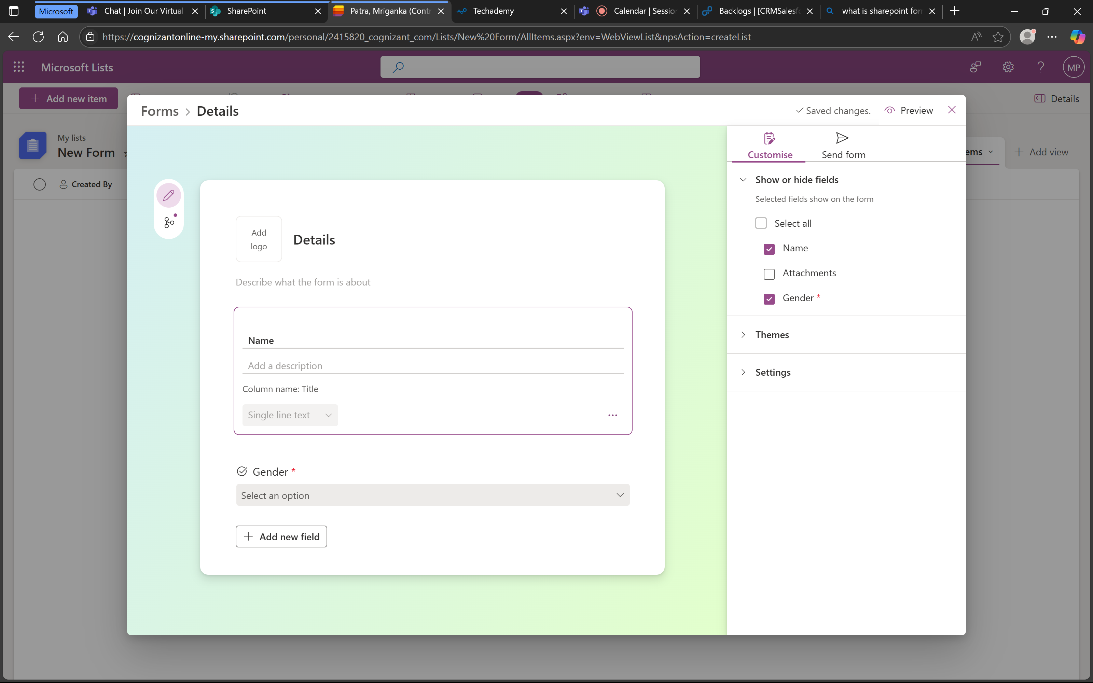

1. When mandatory field gender is not filled it shows error message.

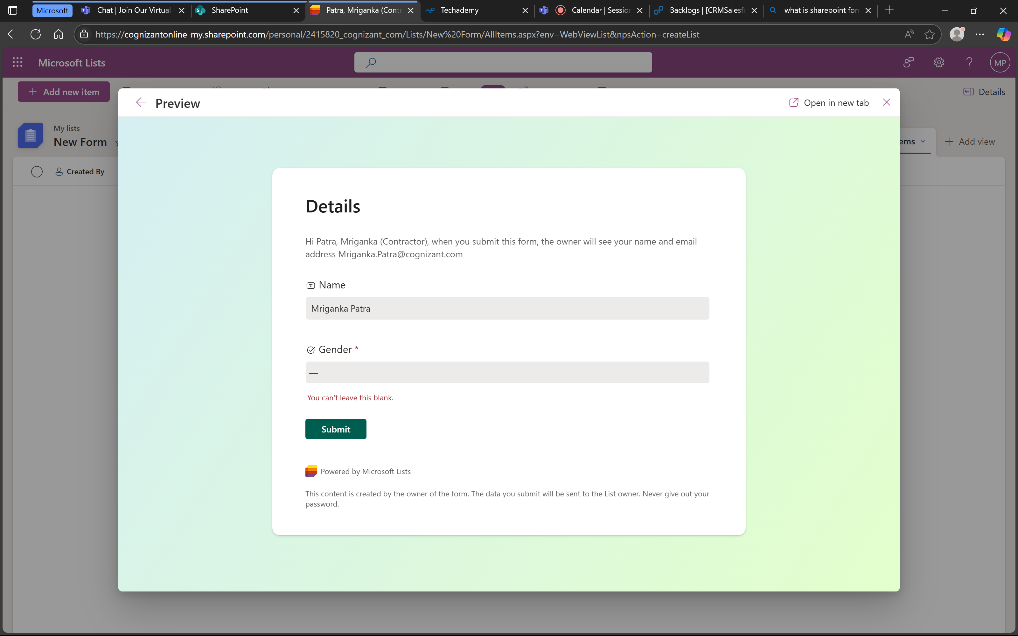

1. Means that the form is working successfully.

**Test Case 2: Data Type Validation - Invalid Input**

Description: Verify that the form correctly validates input for specific data types (e.g., names, gender) and displays error messages for invalid entries.

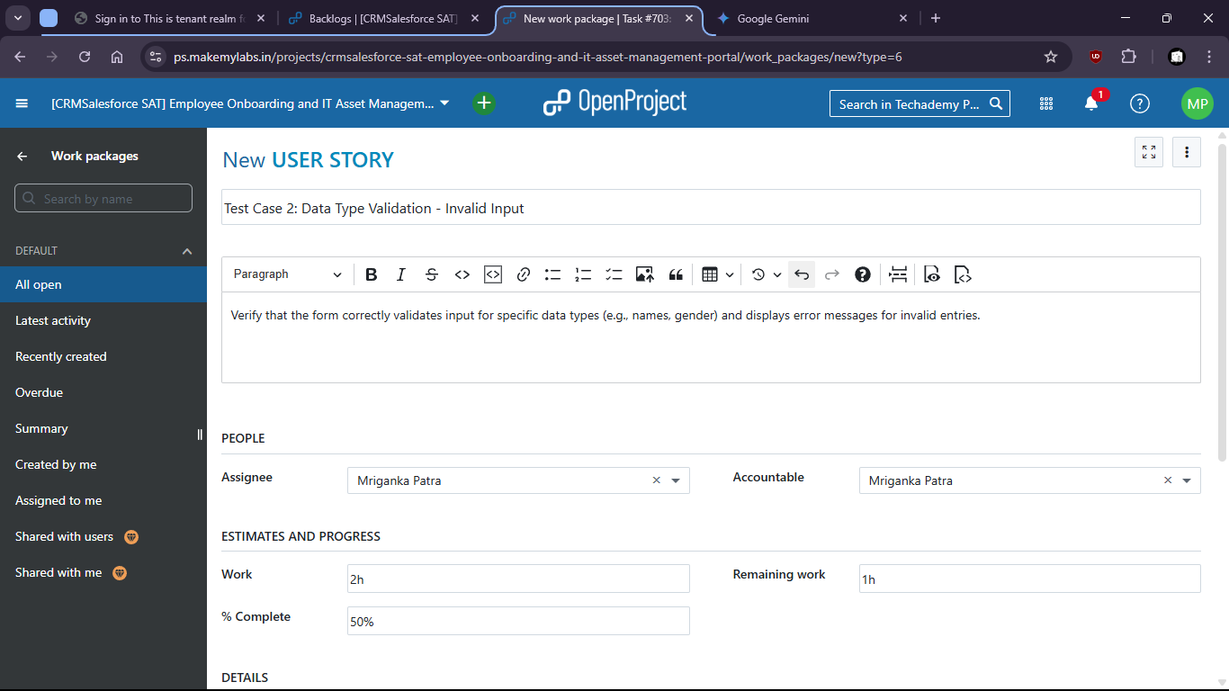

1. There is no option to put invalid data and submit wrong format.
2. Try to put invalid data in the filed like gender

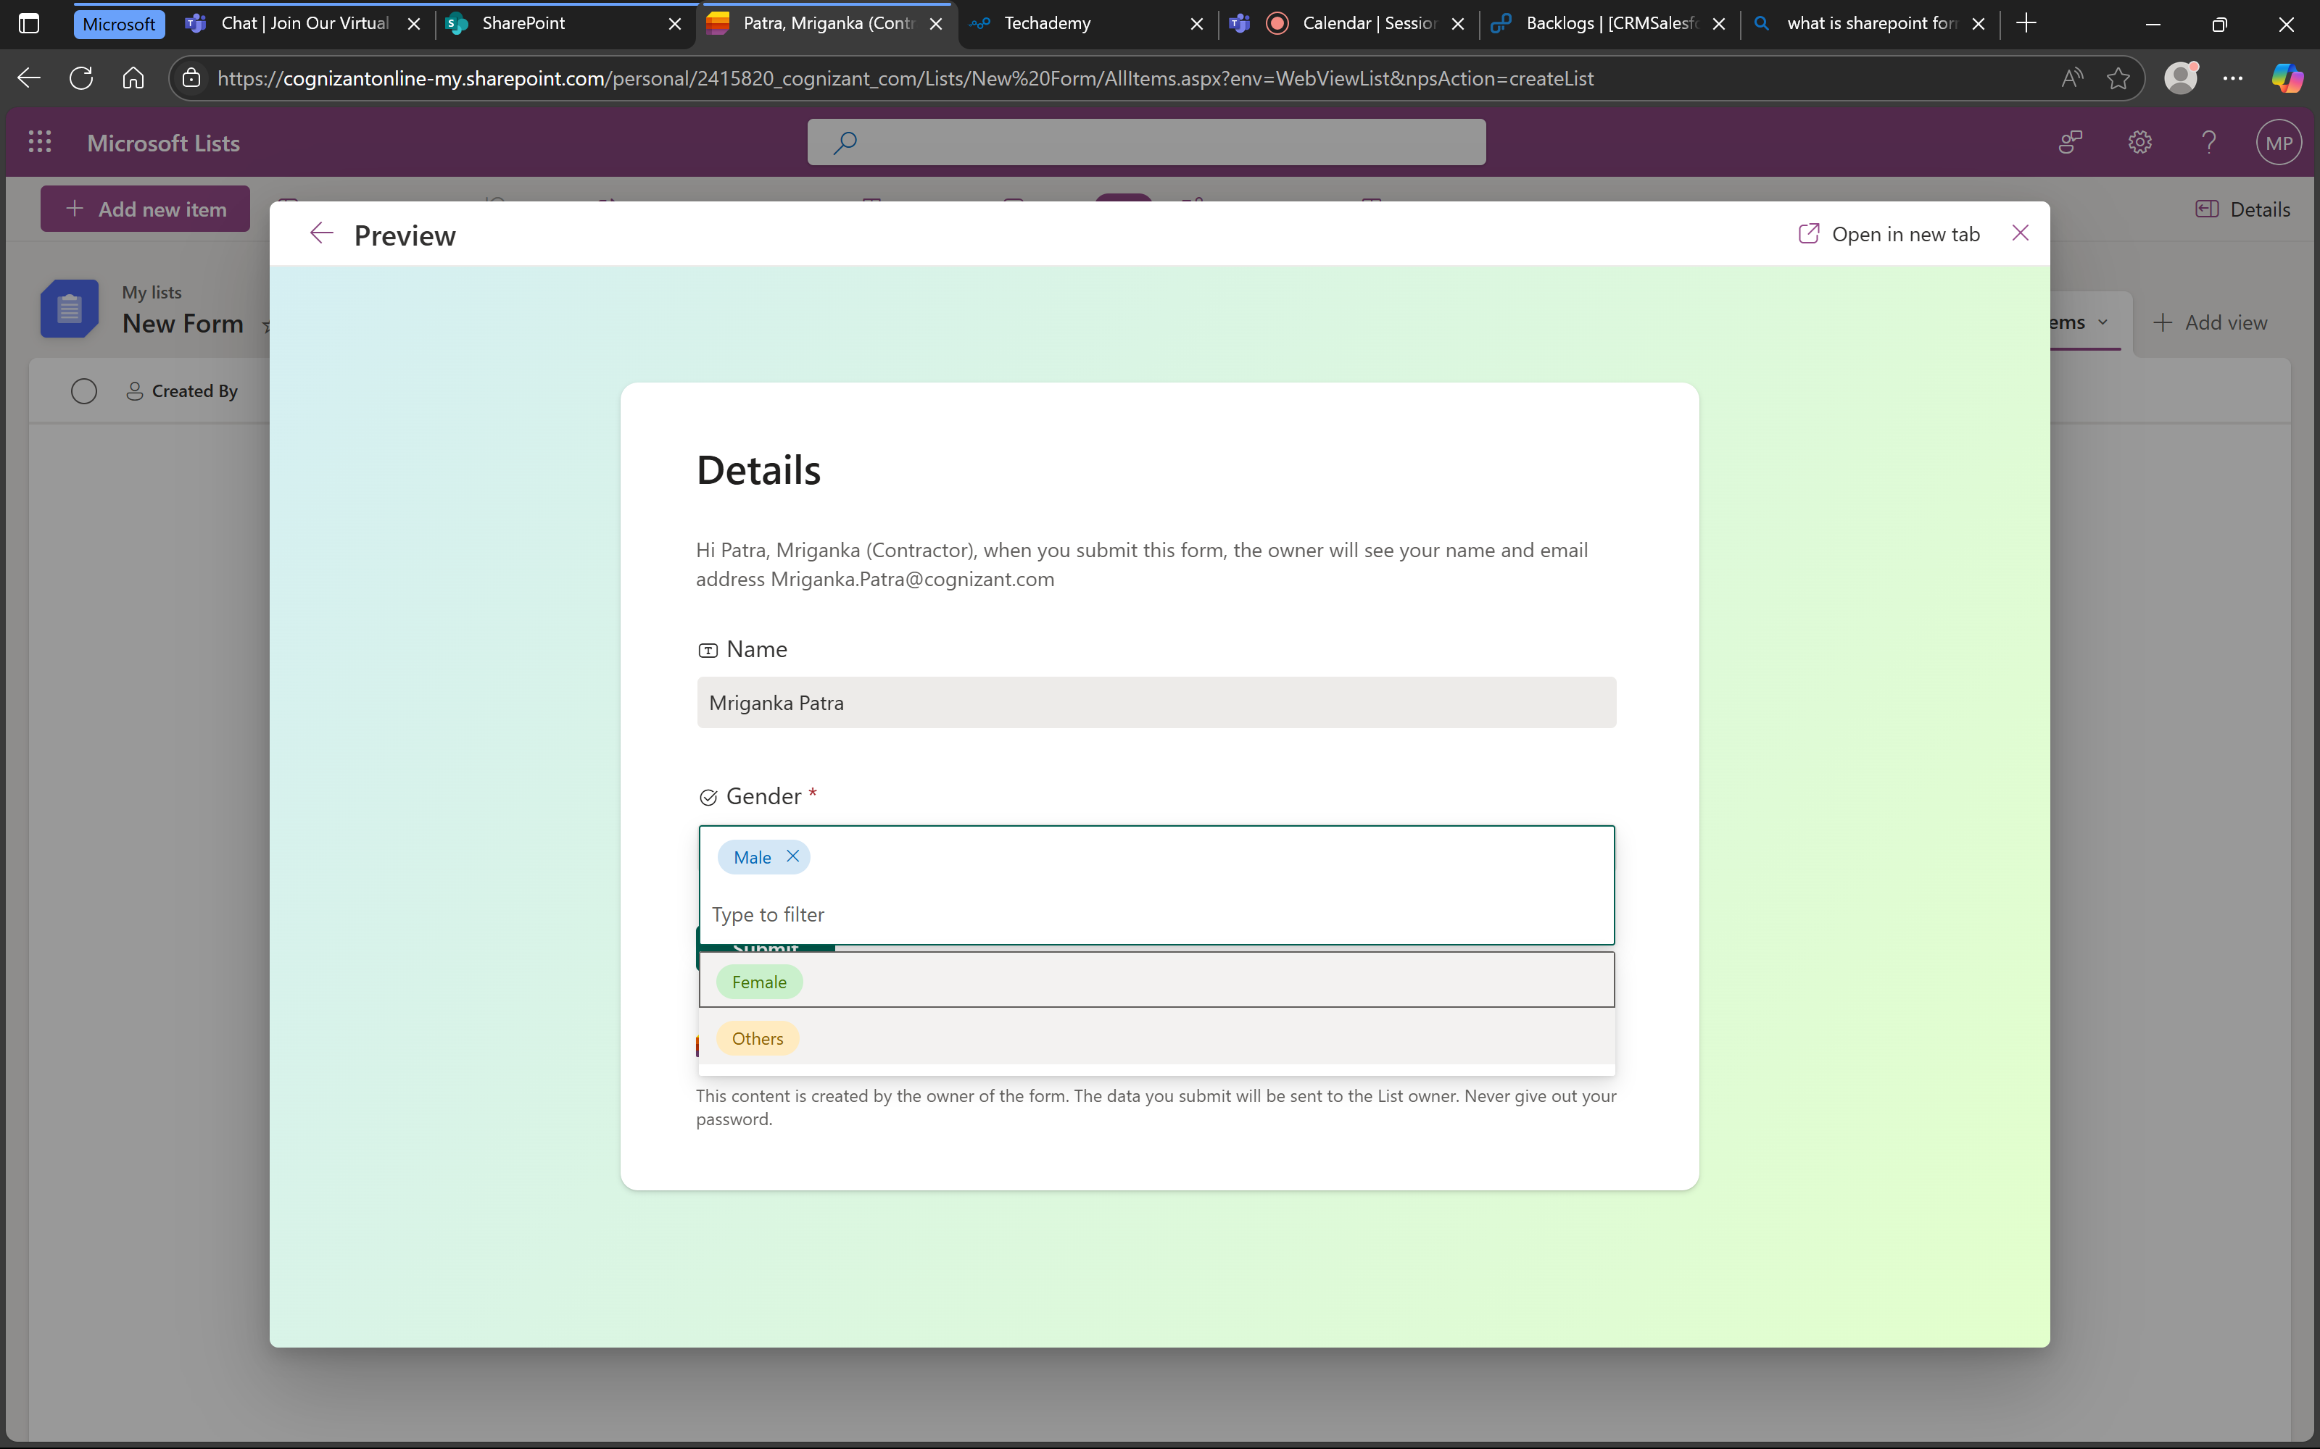

1. There is no option to put invalid data.

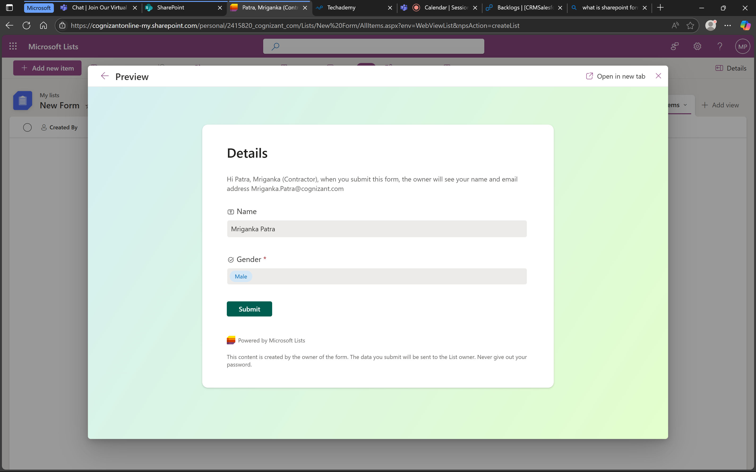

1. That means the test is success and form is working as expected.

**Test Case 3: Form Submission - Successful Submission**

Description: Verify that a new item can be successfully created and saved through the SharePoint form.

1. Check if the form is being submitted successfully.

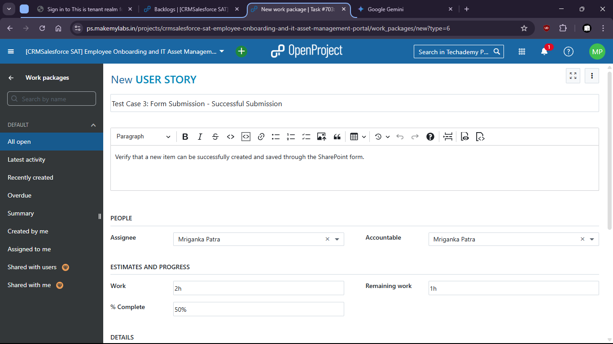

1. Put valid data and submit the form.

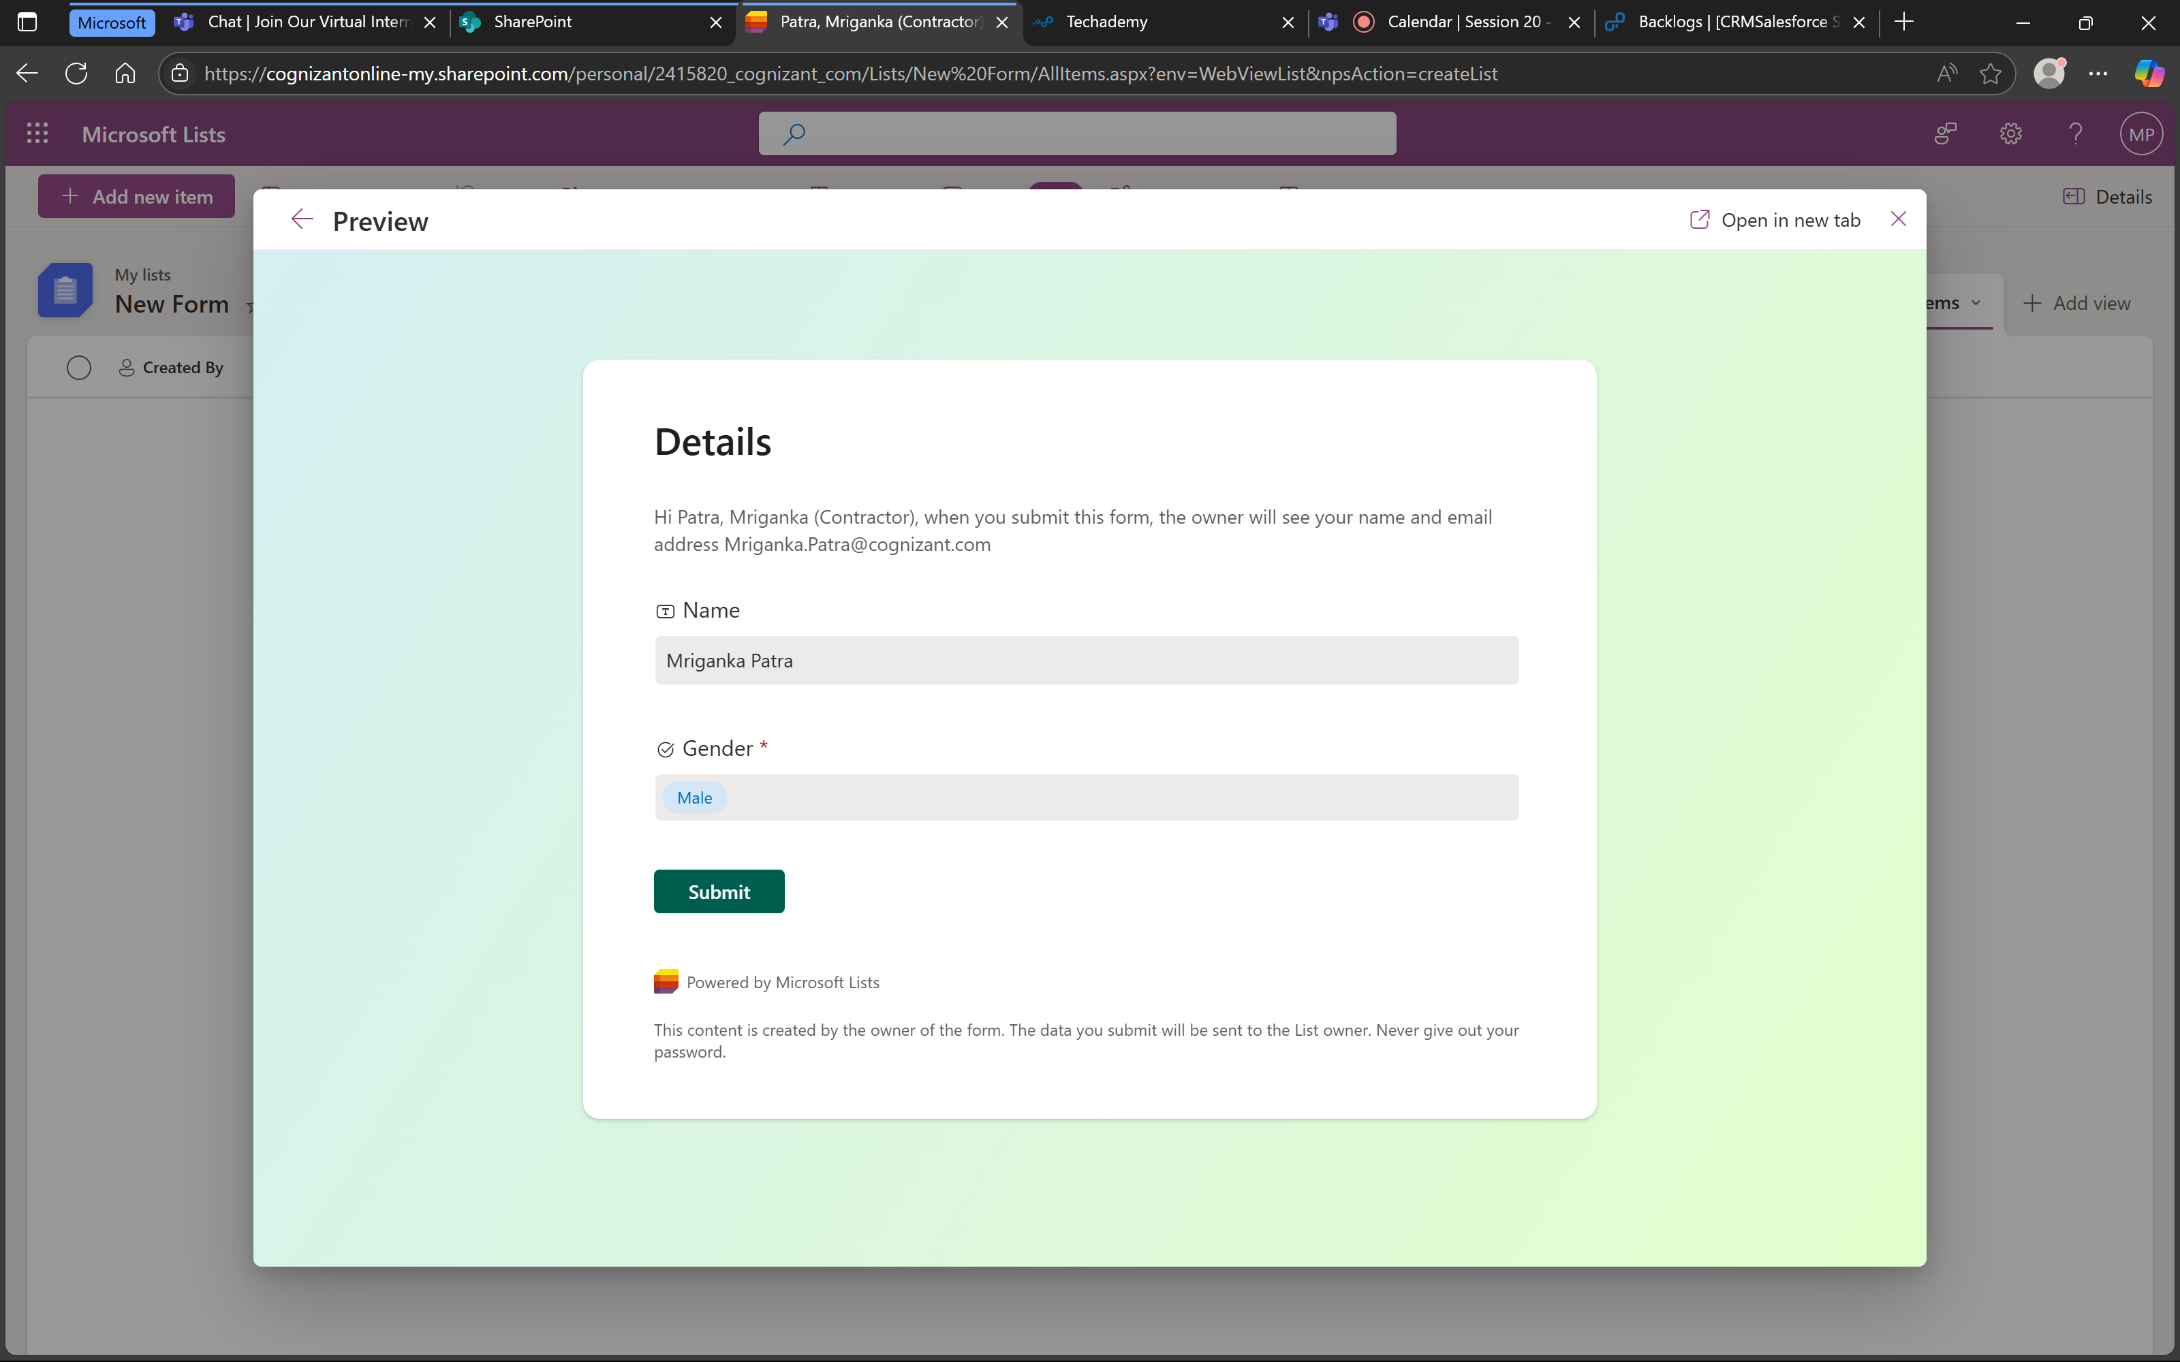

1. Form is submitted.

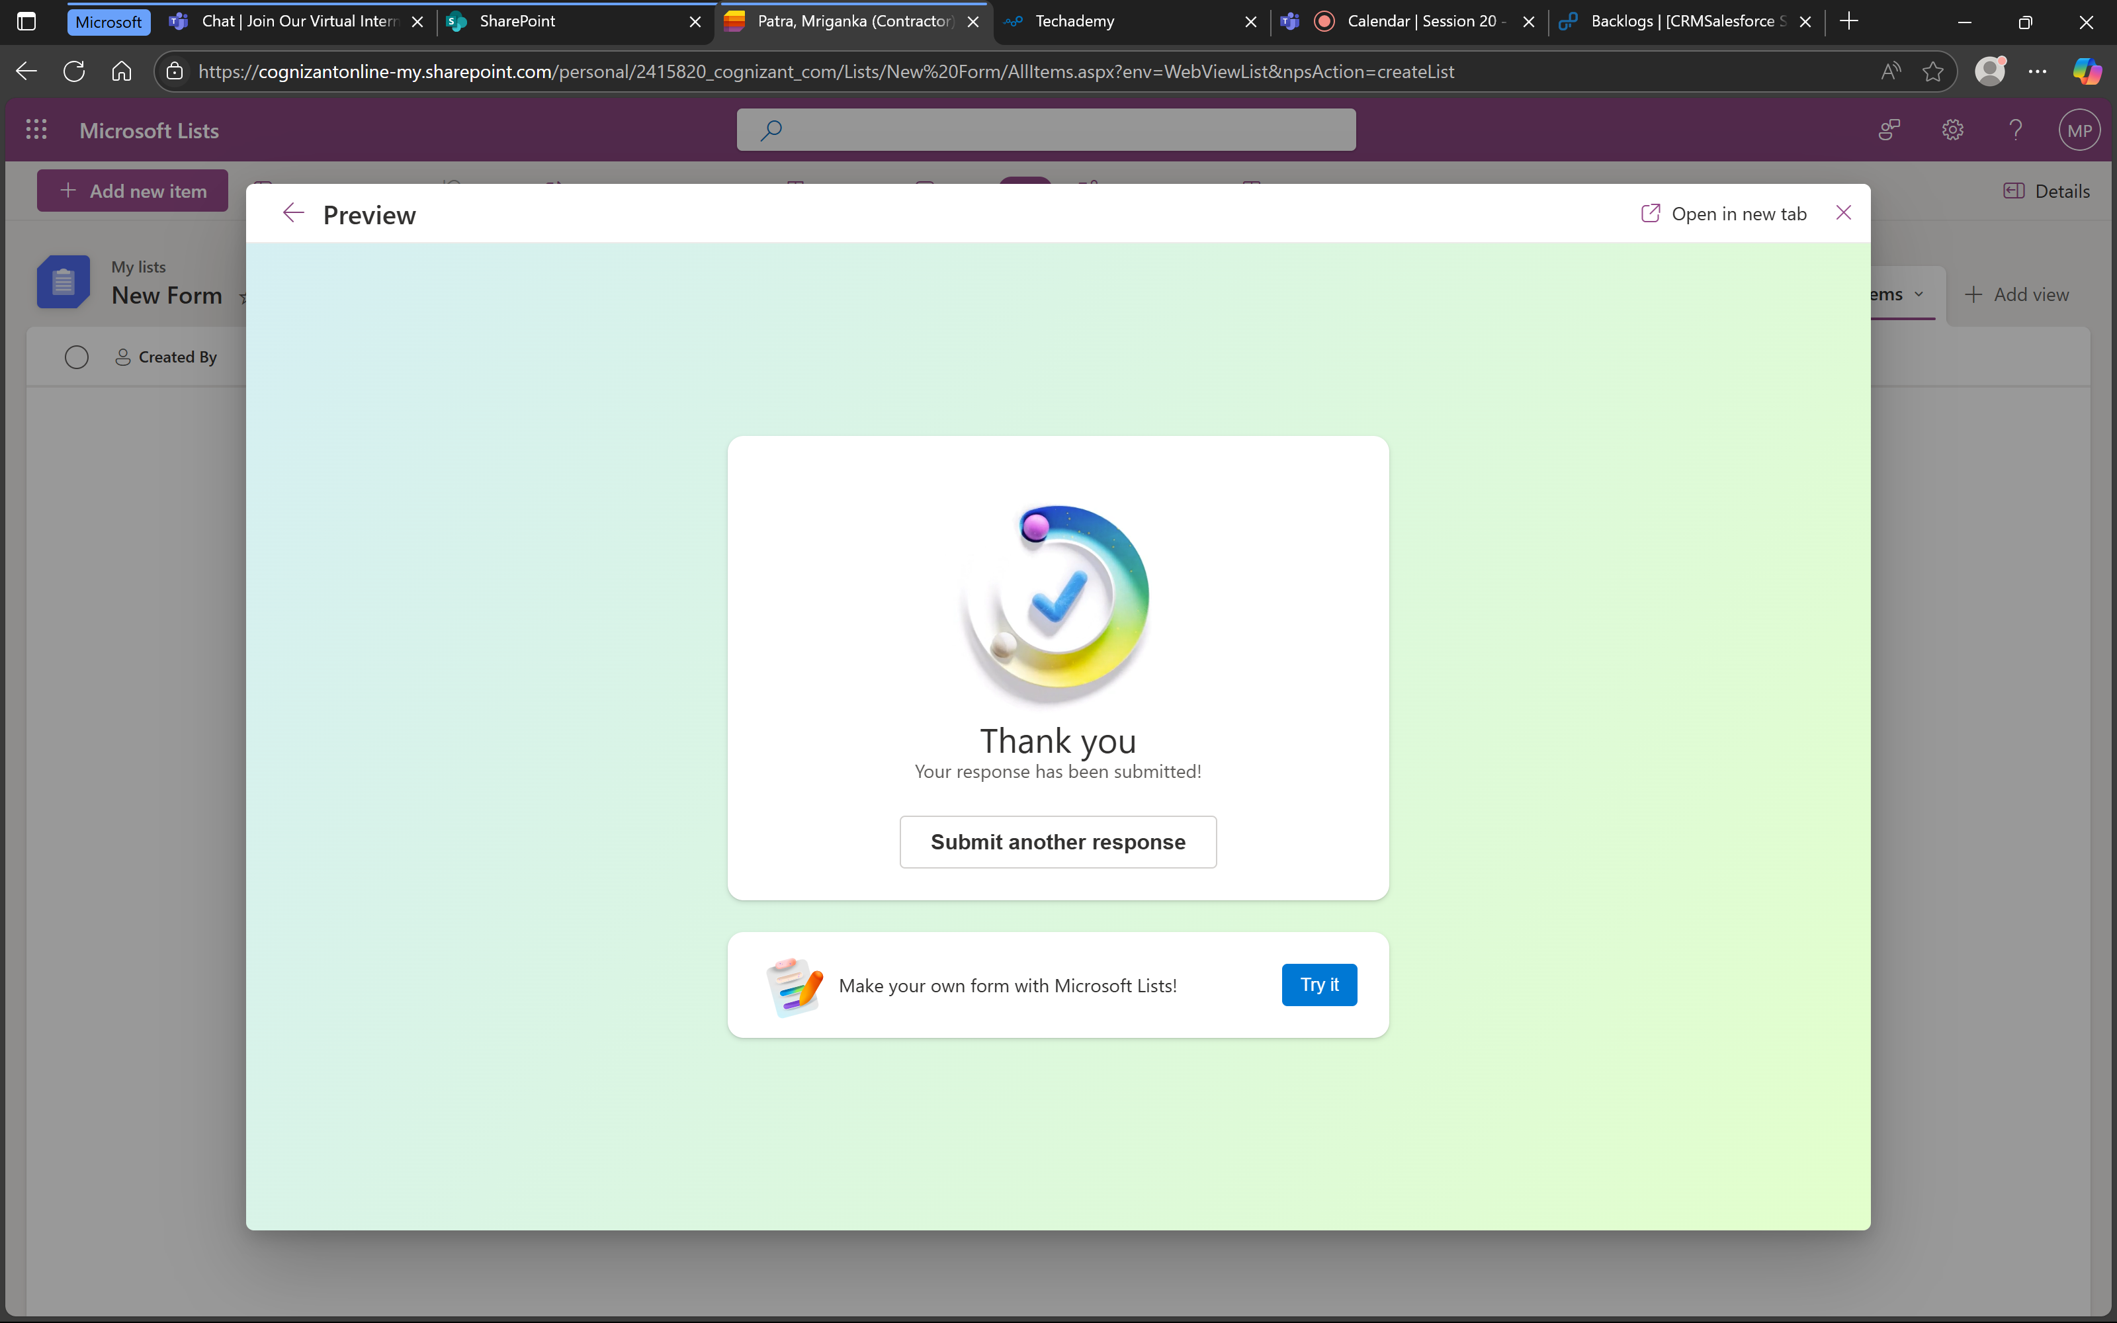

1. Values are also stored successfully.

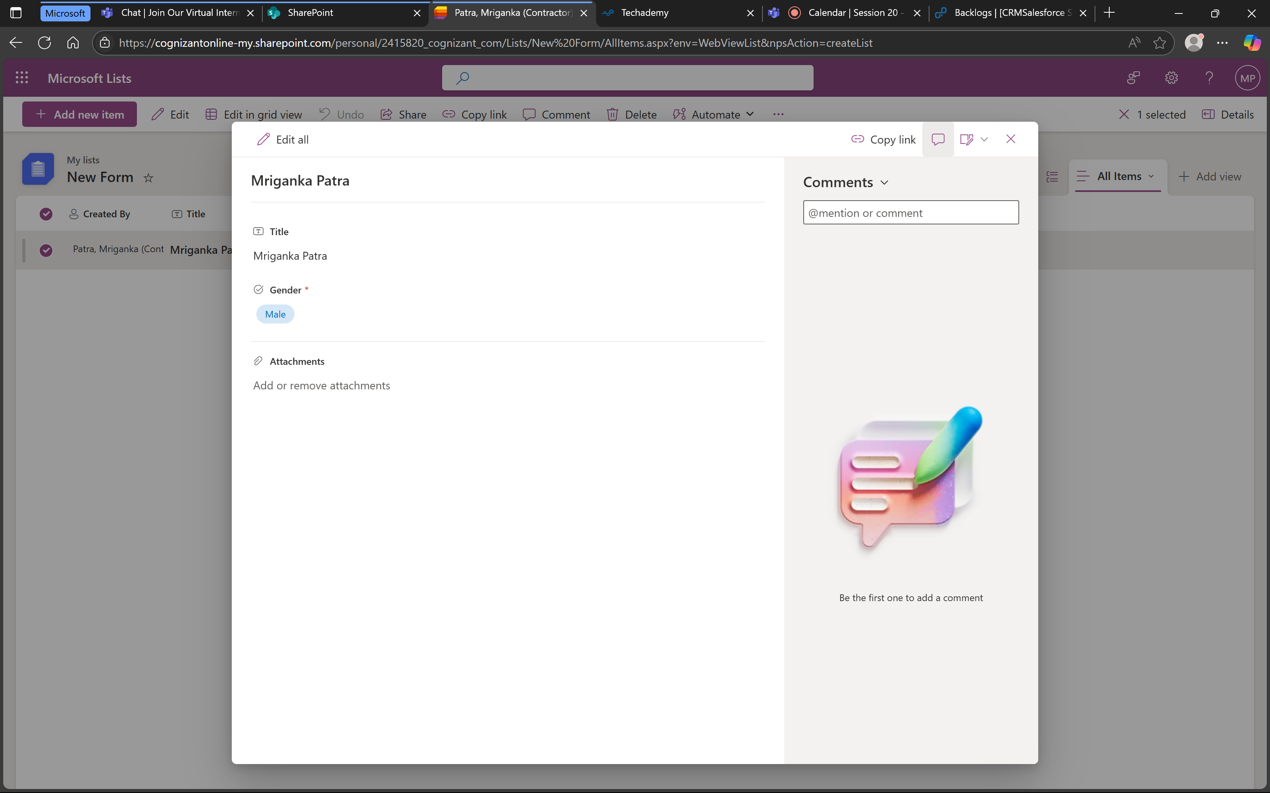

1. That means the form is working successfully.

**Test Case 4: Form Cancellation**

Description: Verify that the form can be cancelled without creating an item.

1. Check if after cancellation the data is being cleared.

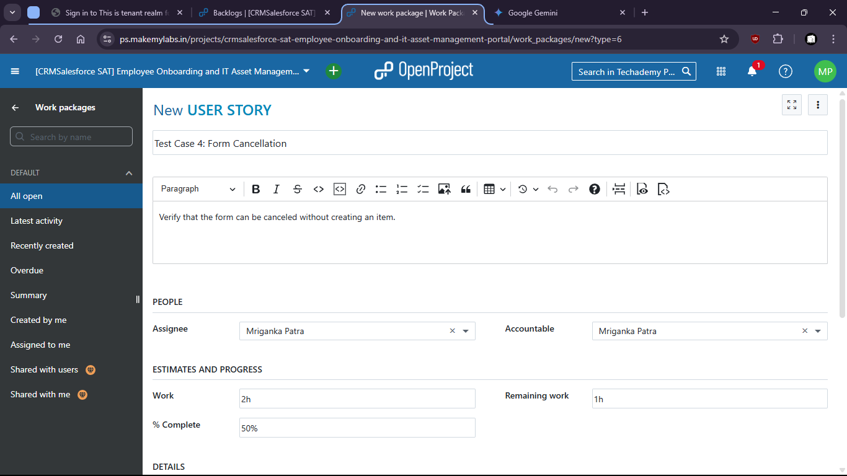

1. Form is filled up

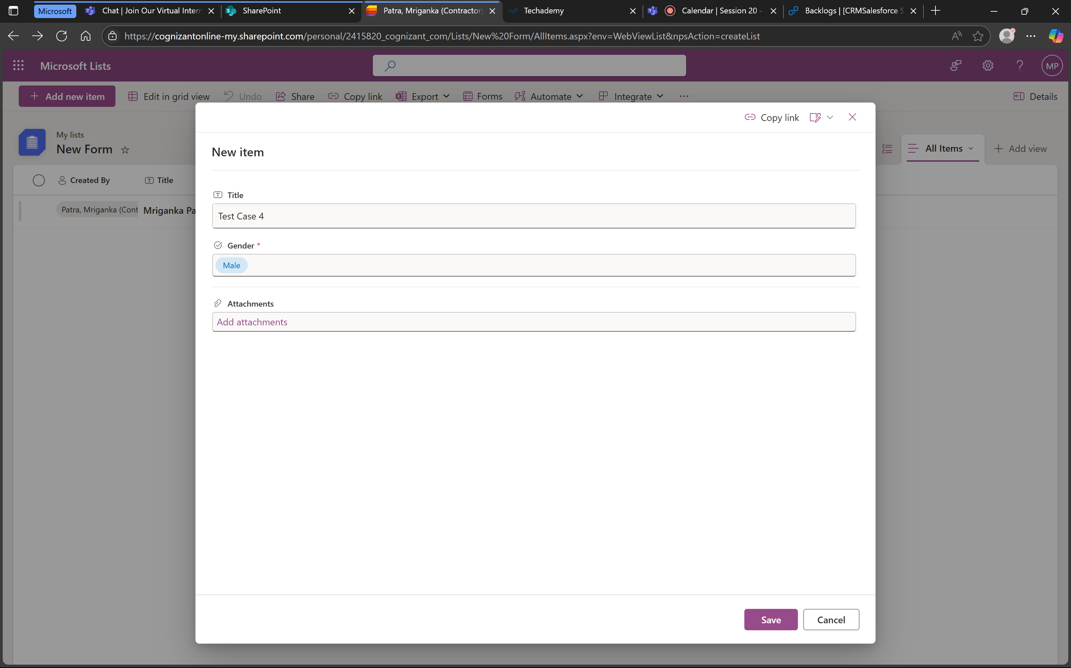

1. Then it is cancelled:

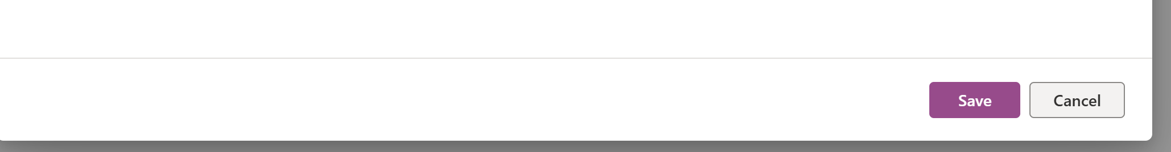

1. We can check that no new form is created

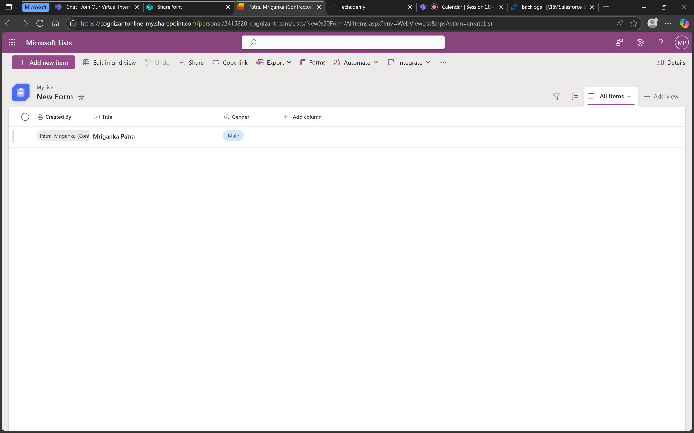

1. That means the form does not store values after cancellation and is working as expected.